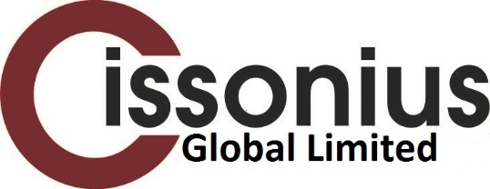

***What you can expect from us:***

The following is by no means an exhaustive list but it will serve to give you an idea as to how we generally conduct our business with you.

You will receive a business card with contact details and we will take you through the relevant disclosure documents which outline what we are authorised to do, how we can be paid, data protection and complaints issues, among other things.

We will then complete a confidential Fact Find on your circumstances, which records all your relevant personal and financial details. You can choose which areas you wish to address. However, the more you can tell us, the more appropriate our advice will be as we base our recommendations on this document. If there is an investment element to what you want to do, we will also ask you to complete a Risk Profiler which gives us an idea of your attitude to risk and helps us to highlight the best funds for you. We will also ask for appropriate forms of identification and residential address verification.

If we recommend a product, you will receive a copy of the research, a Key Facts/Features document which covers generic details and a personalised illustration. The illustration shows details of the product, including such things as plan charges, term of contract, cancellation rights and commission, if applicable. (If a product switch is involved, we will complete a form which highlights the reason for the switch.) Only after you are happy with these will we proceed to the application form. We will then outline the usual procedures and checks – e.g. medical details confirmation – which then follow.

Within 5 working days, we will forward a Suitability Report which will set out your situation, your wishes/needs and the steps which have been taken to fulfil these. This report will confirm your preferred method of payment and the amount. You will receive a form asking you to verify that this report is a correct summary of our business and that you agree with the outcome. We will also send you a questionnaire about your experience of our company for completion. We use this to improve our service.

We will also confirm the post advice service and the ongoing relationship which we will have with you, based on your wishes. This could be annual statements or regular face-to-face reviews.

The above are the basic steps in the usual process. If your case is in any way different – e.g. Execution Only, where you tell us what you want and do not require advice – then we will explain that process at the outset.

***We hope that you find this useful.***

***Cissonius Global Limited.***